WEB COMPUTING
1. Web Programming Fundamentals
1.1 Working of web browser, HTTP protocol, HTTPS, DNS, TLS, XML introduction, Json introduction, DOM, URL, URI, REST API
PAST QUESTIONS:
- Explain the working of DNS with the suitable diagrams. Clearly explain all the steps involved in DNS resolution. (D22)
- What is HTTP? Explain its working along with request and response example. (M23)
- Write an XML file marksheet.xml representing your semester mark sheet. How do you prove that it is well formed and valid XML? (M23)
- Draw and illustrate 3-tier web architecture. (M23, D23)
- Write a short note on Document Object Model(DOM). (D23)
NOTES:

*3-tier web architecture :-
The three-tier architecture of web applications is a widely used framework that organizes the components of a web application into three distinct layers, each with specific responsibilities. These layers work together to deliver dynamic and scalable web applications, and each layer can be developed, updated, or maintained independently.
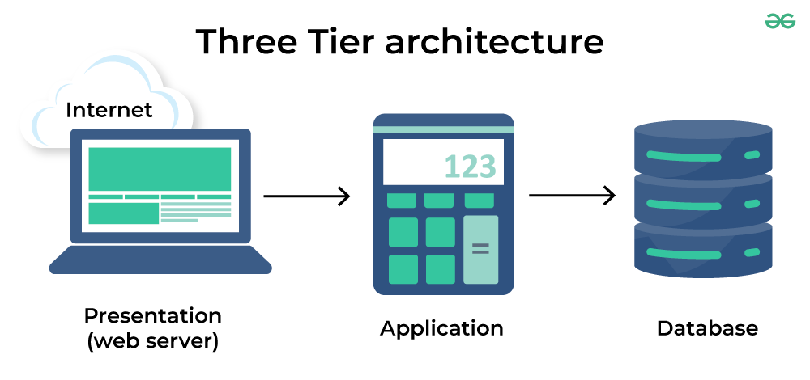
1. Presentation Layer (Client Tier)
- Description: This layer is the user interface that interacts directly with the users.
- Responsibilities:
  - Displays information and allows users to interact with the application.
  - Collects input from users and sends it to the application layer for processing.
- Technologies Used:
  - HTML, CSS, JavaScript, and various frontend frameworks like React, Angular etc.
  - This layer runs on the client-side, usually in a web browser.
2. Application Layer (Business Logic Tier / Middle Tier)
- Description: This layer contains the business logic of the application, which defines how data is processed, validated, and managed.
- Responsibilities:
  - Receives requests from the presentation layer and processes them by interacting with the data layer.
  - Implements business rules, logic, and decision-making.
  - Ensures data is correctly processed and prepares responses for the client.
- Technologies Used:
  - Server-side languages and frameworks like Python (Django, Flask), Java (Spring), Node.js, Ruby on Rails, and PHP (Laravel).
  - Middleware services and APIs may also reside here to handle specific processing tasks.
3. Data Layer (Database Tier)
- Description: This is back-end tier of a web application that consists all the data and is responsible for storing, retrieving, and managing the data required by the application.
- Responsibilities:
  - Stores data in a structured format and allows the application layer to access and manipulate this data as needed.
  - Ensures data integrity, security, and availability.
  - Manages data transactions and handles any data recovery requirements.
- Technologies Used:
  - Relational databases like MySQL, PostgreSQL, and Oracle; NoSQL databases like MongoDB.

*Working of Web Browser :-
The web browser is an application software to explore www (World Wide Web). It provides an interface between the server and the client and it requests to the server for web documents and services. It works as a compiler to render HTML, CSS stylesheets and JavaScript functions which are used to design a webpage.
A web browser helps us find information anywhere on the internet.
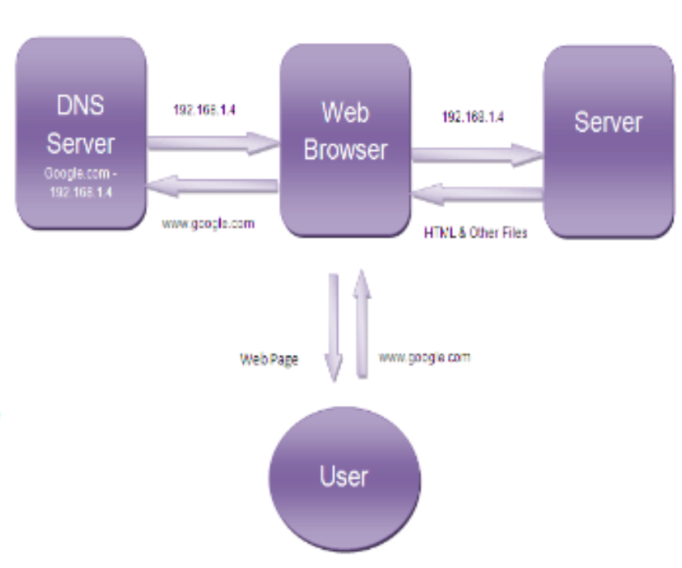
Working –
1. Contact to DNS Server: Browser contacts DOMAIN NAME SERVER which returns page IP Adress.
2. Contact to Server – After getting the IP address of the server for the requested webpage, browser sends a request to that server for the desired files.
3. Rendering – The entire process followed by a browser from fetching the webpage to displaying it on the screen is called Rendering.
*Domain Name Server (DNS) :-
A DNS (Domain Name System) server translates domain names into IP addresses, allowing users to access websites by typing domain names into their web browsers.
DNS resolves names to numbers, to be more specific it resolves domain names to IP addresses. So if you type in a web address in your web browser, DNS will resolve the name to a number because the only thing computers know are numbers.
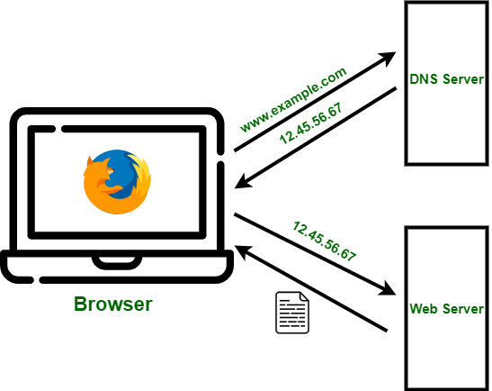
when you type google.com on your web browser DNS server will search through its cache to find a matching IP address for that domain name, and when it finds it will resolve that domain name to IP address of Google web site, and once that is done then your computer is able to communicate with a Google web server and retrieve the webpage.
Working:
- User enters a domain name: When a user types a domain name into their browser, the DNS server finds the corresponding IP address for the website.
- Browser uses the IP address: The browser uses the IP address to send data to the origin servers.
- User accesses the website: The user can now access the information on the website.

*Hypertext Transfer Protocol (HTTP) :-
HTTP stands for “Hypertext Transfer Protocol”. HTTP provides a standard between a web browser and a web server to establish communication. It is a set of rules for sharing data on the World Wide Web (WWW). HTTP helps web browsers and servers communicate, allowing people to access and share information over the internet.
Key Points
- Basic Structure: HTTP forms the foundation of the web, enabling data communication and file sharing.
- Web Browsing: Most websites use HTTP, so when you click on a link or download a file, HTTP is at work.
- Client-Server Model: HTTP works on a request-response system. Your browser (client) asks for information, and the website’s server responds with the data.
- Application Layer Protocol: HTTP operates within the Internet Protocol Suite.
Working:
First of all, whenever we want to open any website we first open a web browser after that we will type the URL of that website (e.g., www.facebook.com). This URL is now sent to the Domain Name Server (DNS). Then DNS first checks records for this URL in their database, and then DNS will return the IP address to the web browser corresponding to this URL. Now the browser is able to send requests to the actual server.

HTTP Request - HTTP request is simply termed as the information or data that is needed by Internet browsers for loading a website. There are various things contained in HTTP Request, some of them are listed below.
HTTP Version
- HTTP Version
- URL
- HTTP Method
- HTTP Request Headers
- HTTP Body
HTTP Response - HTTP Response is simply the answer to what a Server gets when the request is raised. There are various things contained in HTTP Response, some of them are listed below.
- HTTP Status Code
- HTTP Headers
- HTTP Body

* eXtensible Markup Language (XML) :-
XML stands for eXtensible Markup Language
XML is a markup language much like HTML
XML was designed to store and transport data
XML was designed to be self-descriptive

Marksheet.xml –
<?xml version="1.0" encoding="UTF-8"?>
<marksheet>
<student>
<name>John Doe</name>
<rollNumber>12345</rollNumber>
<course>Computer Science</course>
<semester>3</semester>
<marks>
<subject name="Mathematics">
<internal>25</internal>
<external>45</external>
<total>70</total>
</subject>
<subject name="Physics">
<internal>20</internal>
<external>50</external>
<total>70</total>
</subject>
<subject name="Computer Science">
<internal>30</internal>
<external>40</external>
<total>70</total>
</subject>
</marks>
</student>
</marksheet>

Explanation of the XML Structure
The root element is <marksheet>.
Inside <marksheet>, we have a <student> element that contains details for a specific student.
<marks> holds multiple <subject> elements, each with details for a specific subject, such as <internal>, <external>, and <total> marks.

To be well-formed, the XML must:
Have a single root element (<marksheet> in this case).
Properly nest and close all tags.
Use unique element names within the same level, or provide attributes (like name in <subject>).
Include an XML declaration (<?xml version="1.0" encoding="UTF-8"?>).

To make this XML file valid, it must conform to a schema definition, either:
DTD (Document Type Definition) - An older XML validation method.
XSD (XML Schema Definition) - A more powerful and preferred validation method.

If the XML document adheres to the XSD without errors and is correctly structured, it is both well-formed and valid.

*Document Object Model (DOM) :-
HTML DOM (Document Object Model) is a hierarchical representation of HTML documents. It defines the structure and properties of elements on a webpage, enabling JavaScript to dynamically access, manipulate, and update content, enhancing interactivity and functionality.
HTML is used to structure the web pages and JavaScript is used to add behaviour to our web pages. When an HTML file is loaded into the browser, the JavaScript can not understand the HTML document directly. So it interprets and interacts with the Document Object Model (DOM), which is created by the browser based on the HTML document.
DOM is basically the representation of the same HTML document but in a tree-like structure composed of objects. Each branch of the tree ends in a node, and each node contains objects. Event listeners can be added to nodes and triggered on an occurrence of a given event.
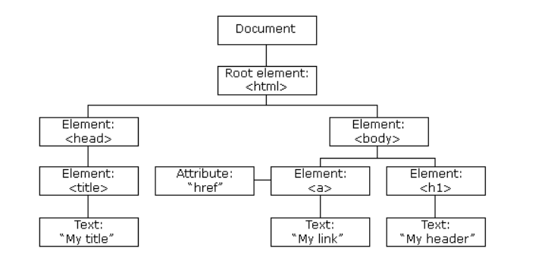
Methods of Document Object
DOM provides various methods that allows users to interact with and manipulate the document. Some commonly used DOM methods are:
Method | Description
getElementById() | Returns the element having the given id value.
getElementsByClassName() | Returns all the elements having the given class name.

*json vs XML :-

